Database for a digital support store
by Zoe Matrullo and Kilian Schulz

Given the task to build a database, capable of handling the day to day business of a store offering digital support, we first had to define our goals for the project. For us, the main points consist in:

- intuitive division according to the third normal form, as much as it makes sense
- easy insertion of values, corresponding to general actions upon the database
- keeping track of different relationships between tables in an easy and efficient way
- having realistic tables and attributes, that might be used in a real digital support store

That in mind and a red bull in the stomach, we set off to achieve exactly that. We used a top-down approach as learned in class, in order to create the following Entity Relationship Model:

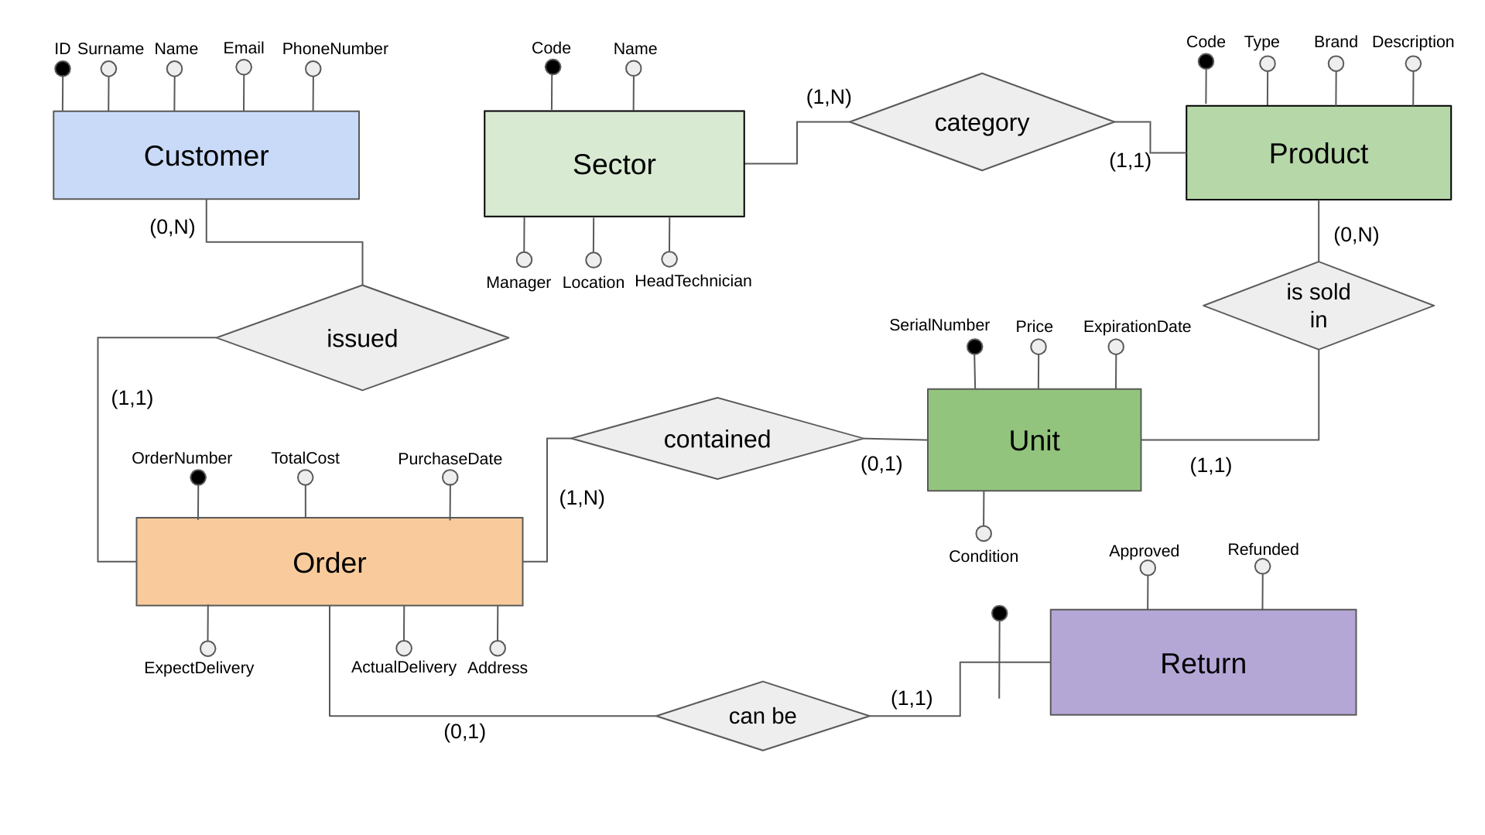

As you can see, we wanted to focus on useful relations in order to paint a true picture of the day to day operations in a digital support store. We have the table CUSTOMER, which is supposed to hold any information needed about people buying at the store. The CUSTOMER can issue orders, those orders can be returned and thus added to the table RETURN, and inside of each order there are different UNIT objects contained. Each UNIT is part of a PRODUCT (the UNIT refers to the actual object in store, while the PRODUCT is the kind of PRODUCT that UNIT is). Each PRODUCT can then belong to a SECTOR, according to what kind of category the PRODUCT belongs to.

As a relational schema. we write our database like this:

CUSTOMER(ID, Surname, Name, Email, PhoneNumber)
ORDER(OrderNumber, IDCustomer, TotalCost, PurchaseDate, ExpectedDelivery, ActualDelivery, Address)
RETURN(IDOrder, Approved, Refunded)
SECTOR(Code, Name, Manager, Location, HeadTechnician)
PRODUCT(Code, Type, SectorCode, Brand, Description)
UNIT(SerialNumber, Product, Price, ExpirationDate, Condition, IDOrder)

ORDER(IDCustomer) ⊆ CUSTOMER(ID)
PRODUCT(SectorCode)⊆SECTOR(Code)
UNIT(IDOrder)⊆ORDER(OrderNumber)
UNIT(Product)⊆PRODUCT(Code)
RETURN(IDOrder)⊆ORDER(OrderNumber)

We made the conscious decision to implement relations more as foreign keys, then as separate tables, since we do not have any N to N relations and thus don’t need to unnecessarily complicate things.

We also defined a trigger, which, upon inserting a Unit that references an Order, updates the TotalCost attribute of said Order by the Product it references.

In SQL, we use the following code to implement the necessary tables:

